Michael Balestra
Home address
Email : michaelbalestra02mail.com Via dei mille 123
Italy
Mobile: +39 3311414218 San benedetto del Tronto (63074)
11/10/1990
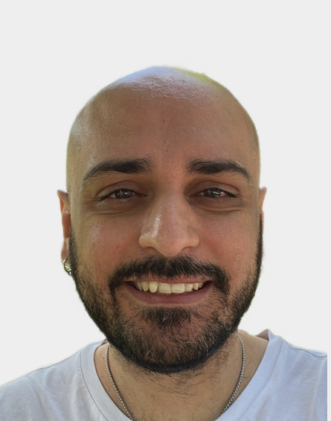

Pizza chef helper italian who has always dreamed of America. Qualified and with the title of Pizza chef but also with knowledge in the preparation of sauces for pasta (carbonara, gricia , Bolognese etc..).I know exactly how to move in a restaurant, i guarantee reliability, seriousness and dedication to work to grow professionally and as a person and willingness to do everything that is asked of me. My goal is to have extensive international knowledge in the industry and open my own business in a large country like the USA.
Education
2006-2009 Agricultural expert , Agricultural Technical Institute Celso Ulpiani (high school) ,
Ascoli Piceno, Italy.
Subjects studied:
Maths, Italian Literature, Zootechnics, Chemistry, Biology, History, English language,
Geography, Crops, Ecology.

2010-2014 Enrollment at the University of Rome "La Sapienza" at the Faculty of Law but without obtaining a
degree

Work Experience
August 2024 - Present Carassai Pharmacy, Carassai, Italy
Responsabilites : - Excellent inventory management and ability to store medicines.
- Control of deadlines, checks on the documentation of packages during transport and
ordering of products.
- Result oriented, carrying out daily assistance actions to support doctors through efficient
communication.

October 2024- Present Eclair Pub and Bar , Piane di Morro, Italy
Responsabilities : - Preparation help in the kitchen.
- Cash management.
- Clean and tidy the tables for the next customers.

April 2022 - June 2022 Pizzeria “Big Bang”, Porto d’Ascoli, Italy.
Responsabilities : - General help in the preparation of the dough, in the preparation of pizzas on the plate and
in the filling of them (classic and gourmet flavours.
- Support in the preparation of ingredient lines.
- Creation of innovative blends following traditional recipes.
- Checking, cleaning, sanitizing and daily maintenance of kitchen equipment.

February 2021 – September 2021 Pizzeria “Locanda anno mille”, Villa Curti, Italy
Resoponsabilities : - Same as the pizzeria previously listed plus preparation of Roman pinse cooked on an
electric oven

Extracurricular Activities
Active role as a member of the social promotion association "L'Ingegno di Dedalo" for recreational activities within the community.
Additional skill
- In possession of the pizza chef certificate (issued by the Italian pizza chef academy) and the HACCP
certificate
- Good use of computer (especially Microsoft Word).
- Excellent use of social media for advertising purposes (instagram).
- Knowledge of foreign languages (English Toefl 52, Spanish).
- Italian native speaker.
- Clean italian driving licence.

